

**DHOLE PATIL COLLEGE OF ENGINEERING KHARADI, PUNE**

**Approved by A.I.C.T.E New Delhi, Govt of Maharashtra &**

**Affiliated to Savitribai Phule Pune University, Pune.**

**Accredited with A+ Grade by NAAC**

**Department of Information Technology**

**Academic Year 2021-22**

**Semester-IV**

DATABASE MANAGEMENT SYSTEM

**MINI PROJECT**

**REPORT**

**ON**

**Second Year Engineering**

**Year 2021-2022**

**Group Members:** 1. Chavan Prasad Suresh

2. Pore Akash Mohan

3. Zanjurne Pratik Sunil

4. Dhakate Siddhant

5. Bhongale Aditya

**Project Title :** Student Management System

**(** DPES Feedback Form)

**Guided By :** Prof. Miss. Nehali Shinde

# 

# Second Year IT E ngineering

### SUBMITTED BY

1. Chavan Prasad Suresh

2. Pore Akash Mohan

3. Zanjurne Pratik Sunil

4. Dhakate Siddhant

5. Bhongale Aditya

# DEPARTMENT

# INFORMATION TECHNOLOGY

**DHOLE PATIL COLLEGE OF ENGINEERING**

**( KHARADI, PUNE )**

**Table of Contents**

|  |  |  |
| --- | --- | --- |
| **Sr. no** | **Contents** | **Page no.** |
| 1 | Abstract | 05 |
| 2 | Introduction | 05 |
| 3 | Software Requirement Specifications | 06 - 07 |
| 4 | Conceptual Design using ER feature | 07 |
| 5 | Relational Model with appropriate Normalized form | 08 |
| 6 | Graphical User Interface | - |
| 7 | Source Code | 08 - 19 |
| 8 | Test Cases Queries | 20 - 21 |
| 9 | Conclusion | 22 |
| 10 | References | 22 |

1. **ABSTRACT**

The Online Student Feedback System is used to manage feedback provided by students. Online Student Feedback System allows students to select particular subject and respective teacher to give feedback about teacher and subject.

A Online Student Feedback System is an feedback generation system which gives proper feedback to teacher provides the proper feedback to the teachers about their teaching quality on basis of rating very poor, poor, average, good, very good. In the existing system students requires giving feedback manually. In existing system report generation by analyzing all feedback form is very time consuming. By Online Student Feedback System report generation is consumes very less time. In Online Student Feedback System student gives feedback for teacher of particular subject for particular period of time may be at month end. Feedback is send to HOD (Head of the Department) of particular department as well as all departments’ feedback to principal. HOD has rights to whether feedback shows to respected teacher or not. After analyzing report HOD or principle conducts the meetings for staff by send mail to them.

**2.INTRODUCTION**

The student management system (DPES Feedback Form) application will help in managing the student’s data will become easier with one such system. It will also help in saving time and effort. The user interface must be user friendly and easy to understand. The information of the particular student will be obtained in just one mouse click. Some of the features that it can include are as follows:

* **Student database management:** The details of the students of the organizations can be stored in the database with the use this application.
* **Security:** The data that will be disclosed will be more secure since there will be no access to the unknown users.
* **One-click access:** You will obtain the details of the students by entering his/her name or the roll number just in one click.
* **User interface:** The user interface must be simple and easy to understand.
* **Personal details:** All the personal details of the students can be obtained in just one mouse click.

1. **HARDWARE / SOFTWARE REQUIREMENT SPECIFICATION**

### HARDWARE REQUIREMENTS

* A desktop or laptop with a proper internet connection.
* 20 GB of hard disk (free space)
* Minimum 2GB or Greater of the RAM
* Operating system.(Windows)

### SOFTWARE REQUIREMENTS:

* **PHP**

**PHP** is a [general-purpose](https://en.wikipedia.org/wiki/General-purpose_programming_language) [scripting language](https://en.wikipedia.org/wiki/Scripting_language) geared toward [web development](https://en.wikipedia.org/wiki/Web_development).[[7]](https://en.wikipedia.org/wiki/PHP#cite_note-7) It was originally created by Danish-Canadian [programmer](https://en.wikipedia.org/wiki/Programmer) [Rasmus Lerdorf](https://en.wikipedia.org/wiki/Rasmus_Lerdorf) in 1994.[[8]](https://en.wikipedia.org/wiki/PHP#cite_note-History_of_PHP-8) The PHP [reference implementation](https://en.wikipedia.org/wiki/Reference_implementation) is now produced by The PHP Group.[[9]](https://en.wikipedia.org/wiki/PHP#cite_note-about_PHP-9) PHP originally stood for ***Personal Home Page***,[[8]](https://en.wikipedia.org/wiki/PHP#cite_note-History_of_PHP-8) but it now stands for the [recursive initialism](https://en.wikipedia.org/wiki/Recursive_initialism) ***PHP: Hypertext Preprocessor***.[[10]](https://en.wikipedia.org/wiki/PHP#cite_note-10)

PHP code is usually processed on a [web server](https://en.wikipedia.org/wiki/Web_server) by a PHP [interpreter](https://en.wikipedia.org/wiki/Interpreter_(computing)) implemented as a [module](https://en.wikipedia.org/wiki/Plugin_(computing)), a [daemon](https://en.wikipedia.org/wiki/Daemon_(computing)) or as a [Common Gateway Interface](https://en.wikipedia.org/wiki/Common_Gateway_Interface) (CGI) executable. On a web server, the result of the [interpreted](https://en.wikipedia.org/wiki/Interpreter_(computing)) and executed PHP code – which may be any type of data, such as generated [HTML](https://en.wikipedia.org/wiki/HTML) or [binary](https://en.wikipedia.org/wiki/Binary_number) image data – would form the whole or part of an [HTTP](https://en.wikipedia.org/wiki/Hypertext_Transfer_Protocol) response. Various [web template systems](https://en.wikipedia.org/wiki/Web_template_system), web [content management systems](https://en.wikipedia.org/wiki/Content_management_system), and [web frameworks](https://en.wikipedia.org/wiki/Web_framework) exist which can be employed to orchestrate or facilitate the generation of that response. Additionally, PHP can be used for many programming tasks outside the web context, such as standalone [graphical applications](https://en.wikipedia.org/wiki/Graphical_user_interface)[[11]](https://en.wikipedia.org/wiki/PHP#cite_note-11) and [robotic](https://en.wikipedia.org/wiki/Robotics) [drone](https://en.wikipedia.org/wiki/Unmanned_aerial_vehicle) control.[[12]](https://en.wikipedia.org/wiki/PHP#cite_note-12) PHP code can also be directly executed from the [command line](https://en.wikipedia.org/wiki/Command-line_interface).

### WEB SERVER: Xampp

**XAMPP** ([/ˈzæmp/](https://en.wikipedia.org/wiki/Help:IPA/English) or [/ˈɛks.æmp/](https://en.wikipedia.org/wiki/Help:IPA/English))[[2]](https://en.wikipedia.org/wiki/XAMPP#cite_note-kaiseidlerinterview-2) is a [free and open-source](https://en.wikipedia.org/wiki/Free_and_open-source) [cross-platform](https://en.wikipedia.org/wiki/Cross-platform) [web server](https://en.wikipedia.org/wiki/Web_server) [solution stack](https://en.wikipedia.org/wiki/Solution_stack) package developed by Apache Friends,[[2]](https://en.wikipedia.org/wiki/XAMPP#cite_note-kaiseidlerinterview-2) consisting mainly of the [Apache HTTP Server](https://en.wikipedia.org/wiki/Apache_HTTP_Server), [MariaDB](https://en.wikipedia.org/wiki/MariaDB) [database](https://en.wikipedia.org/wiki/Database), and [interpreters](https://en.wikipedia.org/wiki/Interpreter_(computing)) for scripts written in the [PHP](https://en.wikipedia.org/wiki/PHP) and [Perl](https://en.wikipedia.org/wiki/Perl) [programming languages](https://en.wikipedia.org/wiki/Programming_language).[[3]](https://en.wikipedia.org/wiki/XAMPP#cite_note-x_mariadb-3)[[4]](https://en.wikipedia.org/wiki/XAMPP#cite_note-4) Since most actual web server deployments use the same components as XAMPP, it makes transitioning from a local test server to a live server possible.

XAMPP's ease of deployment means a [WAMP](https://en.wikipedia.org/wiki/WAMP) or [LAMP](https://en.wikipedia.org/wiki/LAMP_(software_bundle)) stack can be installed quickly and simply on an operating system by a developer, with the advantage that common add-in applications such as [WordPress](https://en.wikipedia.org/wiki/WordPress) and [Joomla!](https://en.wikipedia.org/wiki/Joomla!) can also be installed with similar ease using [Bitnami](https://en.wikipedia.org/wiki/Bitnami" \o "Bitnami).

### Database: MYSQL

**MySQL** ([/ˌmaɪˌɛsˌkjuːˈɛl/](https://en.wikipedia.org/wiki/Help:IPA/English))[[5]](https://en.wikipedia.org/wiki/MySQL#cite_note-whatismysql-5) is an [open-source](https://en.wikipedia.org/wiki/Open-source_software) [relational database management system](https://en.wikipedia.org/wiki/Relational_database_management_system) (RDBMS).[[5]](https://en.wikipedia.org/wiki/MySQL#cite_note-whatismysql-5)[[6]](https://en.wikipedia.org/wiki/MySQL#cite_note-6) Its name is a combination of "My", the name of co-founder [Michael Widenius](https://en.wikipedia.org/wiki/Michael_Widenius)'s daughter,[[7]](https://en.wikipedia.org/wiki/MySQL#cite_note-7) and "[SQL](https://en.wikipedia.org/wiki/SQL)", the abbreviation for [Structured Query Language](https://en.wikipedia.org/wiki/Structured_Query_Language). A [relational database](https://en.wikipedia.org/wiki/Relational_database) organizes data into one or more data tables in which data may be related to each other; these relations help structure the data. SQL is a language programmers use to create, modify and extract data from the relational database, as well as control user access to the database. In addition to relational databases and SQL, an RDBMS like MySQL works with an [operating system](https://en.wikipedia.org/wiki/Operating_system) to implement a relational database in a computer's storage system, manages users, allows for network access and facilitates testing database integrity and creation of backups.

1. **ER DIAGRAM**

Admin

Student

Mang-ed by

1. **RELATIONAL MODEL WITH APPROPRIATE NORMALIZED FORM**

### First Normal Form (1NF)

As the domain of all attributes of all relations in the database has atomic value and no tuples can have a set of these values, all relations are in 1NF.

### Second Normal Form (2NF)

As there is no partial dependency in the database, i.e. all nonprime attributes of a relation are fully functionally dependent on the primary key of the relation schema, all relations are in 2NF.

### Third Normal Form (3NF)

As all relations are in 2NF and no non-prime attribute of a relation schema is transitively dependent on the primary key, all relations are in 3 NF.

1. **GRAPHICAL USER INTERFACE**
2. **SOURCE CODE**

* **FORM:** INDEX.PHP

<?php

$insert = false;

if(isset($_POST['name']))

{

// Set connection variables

$server = "localhost";

$username = "root";

$password = "1234";

// Create a database connection

$con = mysqli_connect($server, $username, $password);

// Check for connection success

if(!$con){

die("connection to this database failed due to" . mysqli_connect_error());

}

// echo "Success connecting to the db";

// Collect post variables

$name = $_POST['name'];

$age = $_POST['age'];

$rollno = $_POST['rollno'];

$class = $_POST['class'];

$branch = $_POST['branch'];

$desc = $_POST['feedback'];

$sql = "INSERT INTO `dbms`.`feed` ( `Name`, `Age`, `Roll No`, `Class`, `Branch`, `Feedback`, `Date`) VALUES ('$name', '$age', '$rollno', '$class', '$branch', '$desc' ,current_timestamp());";

// Execute the query

if($con->query($sql) == true){

// echo "Successfully inserted";

// Flag for successful insertion

$insert = true;

}

else{

echo "ERROR: $sql <br> $con->error";

}

// Close the database connection

$con->close();

}

?>

<!DOCTYPE html>

<html lang="en">

<head>

<meta charset="UTF-8">

<meta name="viewport" content="width=device-width, initial-scale=1.0">

<title>Feedback Form</title>

<link href="https://fonts.googleapis.com/css?family=Roboto|Sriracha&display=swap" rel="stylesheet">

<link rel="stylesheet" href="style.css">

<style>

.btn{

color: white;

background: green;

padding: 8px 12px;

font-size: 20px;

border: 2px solid white;

border-radius: 14px;

cursor: pointer;

}

</style>

</head>

<body>

<img class="bg" src="bg.jpg" alt="DPES">

<div class="container">

<h1>DPES Feedback form</h3>

<p>Enter your details and submit this form to confirm your participation in the Feedback </p>

<?php

if($insert == true){

echo "<p class='submitMsg'>Thanks for submitting your form. We are happy to see you joining us for the Feedback</p>";

}

?>

<form action="index.php" method="post">

<input type="text" name="name" id="name" placeholder="Enter your name">

<input type="text" name="age" id="age" placeholder="Enter your Age">

<input type="rollno" name="rollno" id="rollno" placeholder="Enter your rollno">

<input type="text" name="class" id="class" placeholder="Enter your class">

<input type="text" name="branch" id="branch" placeholder="Enter your branch">

<textarea name="feedback" id="feedback" cols="30" rows="10" placeholder="ENTER YOUR FEEDBACK"></textarea>

<button class="btn">Submit</button>

</form>

</div>

<script src="index.js"></script>

</body>

</html>

* **ADMIN:** LOGING.PHP

<html>

<head>

<title>Admin Login</title>

<link rel = "stylesheet" type = "text/css" href = "style1.css">

</head>

<body>

<!-- <img class="bg" src="bg.jpg" alt="DPES"> -->

<form action="" method="post" name="Login_Form">

<table width="400" border="0" align="center" cellpadding="5" cellspacing="1" class="Table">

<?php if(isset($msg)){?>

<tr>

<td colspan="2" align="center" valign="top"><?php echo $msg;?></td>

</tr>

<?php } ?>

<tr>

<td colspan="2" align="left" valign="top"><h3><center>Login</center></h3></td>

</tr>

<tr>

<td align="right" valign="top">Username</td>

<td><input name="Username" type="text" class="Input"></td>

</tr>

<tr>

<td align="right">Password</td>

<td><input name="Password" type="password" class="Input"></td>

</tr>

<tr>

<td> </td>

<td><input name="Submit" type="submit" value="Login" class="Button3" onClick="location:/display.php"></td>

</tr>

</table>

</form>

<?php session_start(); /* Starts the session */

/* Check Login form submitted */

if(isset($_POST['Submit'])){

/* Define username and associated password array */

$logins = array('akash' => '1234','username1' => 'password1','username2' => 'password2');

$logins = array('prasad' => '****','username1' => 'password1','username2' => 'password2');

/* Check and assign submitted Username and Password to new variable */

$Username = isset($_POST['Username']) ? $_POST['Username'] : '';

$Password = isset($_POST['Password']) ? $_POST['Password'] : '';

/* Check Username and Password existence in defined array */

if (isset($logins[$Username]) && $logins[$Username] == $Password){

/* Success: Set session variables and redirect to Protected page */

$_SESSION['UserData']['Username']=$logins[$Username];

header("location:display.php");

exit;

} else {

/*Unsuccessful attempt: Set error message */

$msg="<span style='color:red'>Invalid Login Details</span>";

}

}

?>

* **ADMIN DISPLAY :** DISPLAY.PHP

<!DOCTYPE html>

<html>

<heed>

<?php include 'links.php';?>

</head>

<body>

<div class="container" style="margin-top:20px">

<div class="row">

<div class="col-md-12">

<div class="panel panel-info">

<h1 class="panel-heading" align="center">Student Details</h1><br>

<div class="panel-body">

<div class='table-responsive'>

<table class='table table-striped'>

<thead>

<tr>

<th>Id </th>

<th>Name </th>

<th>Age </th>

<th>Roll No </th>

<th>Class </th>

<th>Branch</th>

<th>feedback </th>

<th>Date</th>

<!-- <th colspan="2">Operation</th> -->

</tr>

</thead>

<tbody>

</div>

</div><!-- Close panel Body -->

</div> <!-- Close Panel -->

</div>

</div> <!-- Close Row -->

</div>

<tbody>

<?php

include 'connection.php';

$selectquery =" select * from feed";

$query =mysqli_query($con , $selectquery);

$nums = mysqli_num_rows($query);

while($res = mysqli_fetch_array($query)){

?>

<tr>

<td><?php echo $res[0]; ?></td>

<td><?php echo $res[1]; ?></td>

<td><?php echo $res[2]; ?></td>

<td><?php echo $res[3]; ?></td>

<td><?php echo $res[4]; ?></td>

<td><?php echo $res[5]; ?></td>

<td><?php echo $res[6]; ?></td>

<td><?php echo $res[7]; ?></td>

<!-- <td><a href="UPDATE.php?id=<?php echo $res['id']; ?>"data-toggle="tooltip" data-placement="top" title="UPDATE">

<i class="fa fa-edit" aria-hidden="true"></i></a></td>

<td><a href="delete.php?ids=<?php echo $res['id']; ?> "><i class="fa fa-trash" aria-hidden="true"></i></a></td>

</tr> -->

<?php

}

?>

</tbody>

</table>

</div>

</div>

</div>

<script>

// $(document).ready(function(){

// $('[data-toggle="tooltip"]').tooltip();

// });

</script>

</body>

</html>

**SNAPSHOTS:**

**MAIN FORM:**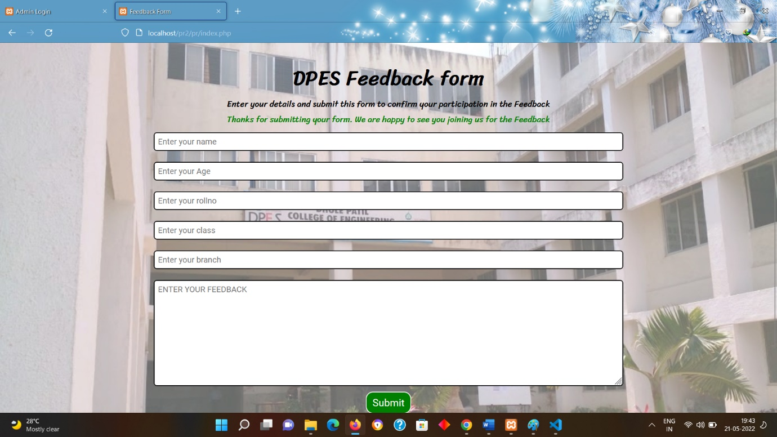

**ADMIN LOGIN:**

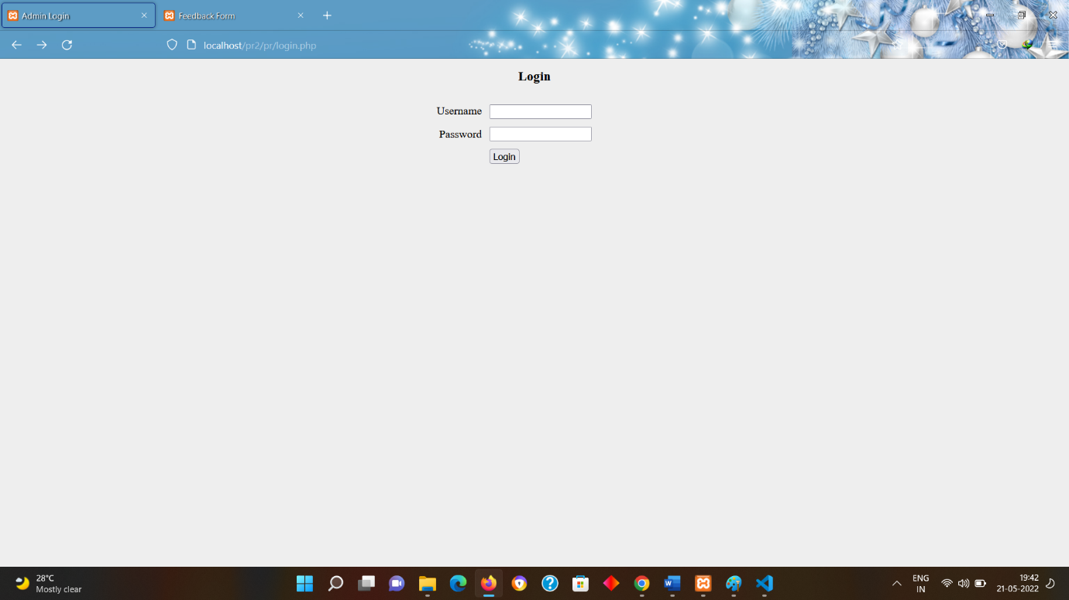

**ADMIN DISPLAY:**

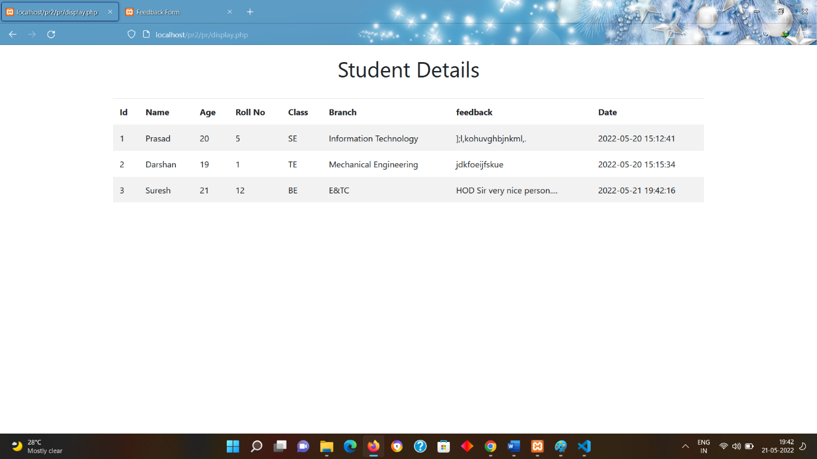

1. **TEST CASES QUERIES**

mysql> show databases;

+--------------------+

| Database |

+--------------------+

| admin |

| bbdms |

| dbms |

| emp_management |

| information_schema |

| mcqexamination |

| model |

| mysql |

| performance_schema |

| phpmyadmin |

| sakila |

| student |

| sys |

| triggers |

| university |

| world |

+--------------------+

16 rows in set (0.04 s)

mysql> use dbms;

Database changed

mysql> describe feed;

+----------+--------------+------+-----+-------------------+-------------------+

| Field | Type | Null | Key | Default | Extra |

+----------+--------------+------+-----+-------------------+-------------------+

| Id | int | NO | PRI | NULL | auto_increment |

| Name | varchar(255) | NO | | NULL | |

| Age | int | NO | | NULL | |

| Roll No | int | NO | | NULL | |

| Class | varchar(255) | NO | | NULL | |

| Branch | varchar(50) | NO | | NULL | |

| Feedback | varchar(255) | NO | | NULL | |

| Date | datetime | NO | | CURRENT_TIMESTAMP | DEFAULT_GENERATED |

+----------+--------------+------+-----+-------------------+-------------------+

8 rows in set (0.02 sec)

mysql> select * from feed;

+----+---------+-----+---------+-------+------------------------+------------------------------+---------------------+

| Id | Name | Age | Roll No | Class | Branch | Feedback | Date |

+----+---------+-----+---------+-------+------------------------+------------------------------+---------------------+

| 1 | Prasad | 20 | 5 | SE | Information Technology | ];l,kohuvghbjnkml,. | 2022-05-20 15:12:41 |

| 2 | Darshan | 19 | 1 | TE | Mechanical Engineering | jdkfoeijfskue | 2022-05-20 15:15:34 |

| 3 | Suresh | 21 | 12 | BE | E&TC | HOD Sir very nice person.... | 2022-05-21 19:42:16 |

+----+---------+-----+---------+-------+------------------------+------------------------------+---------------------+

3 rows in set (0.04 sec)

1. **CONCLUSION**

The Student Feedback System portal is developed to facilitate easy processing of Feedback in educational institutions. Manually, this consumes a lot of time, effort and paper work. And also it is possible to freely submit the feedback without any hesitation. So, this portal overcomes all these limitations and offers a great deal of help at each and every stage in the whole process of availing a leave.

**Modules of Online feedback form**

* Admin  :
* Admin can create Package.
* Manage Data of Users(Students)
* Admin can view daily, weekly and report this module.
* Users :
* Student can register themselves for the feedback by entering the required data such as name, age, roll no, class, branch or any suggestions if they wanted to give.
* This module provide students to enter their.

1. **REFERENCES**

<https://codeshoppy.com/shop/product/student-feedback-system/>

<https://www.w3schools.com/php/php_intro.asp>

<https://en.wikipedia.org/wiki/PHP>

<https://en.wikipedia.org/wiki/XAMPP>

<https://en.wikipedia.org/wiki/MySQL>

<https://github.com/>

You Tube

Google From Images